## Web Content Management

**Lab Time**: 60 minutes

**Lab Folder**: C:\Student\Labs\WCM

**Lab Overview:** In this lab you will start by creating a Publishing Portal and changing its look and feel. Then you will create custom page layouts which can be used to create publishing pages. Lastly, you will learn how the approval process works in publishing sites.

**Lab Setup Requirements**

* Before you begin this lab, you must run the batch file named **SetupLab.bat**. This batch file does a few setup steps for the lab.

### Exercise 1: Creating a Publishing Portal

In this exercise you will create a publishing portal using the Publishing Portal Template. Then you will customize its look and feel.

1. Open **SharePoint 2010 Central Administration**.
2. Under the **Application Management** section click **Create site collection** and use the following to create the new site collection:

**Web Application**: http://intranet.wingtip.com

**Title:** Adventure Works

**URL:** http://intranet.wingtip.com/sites/AdventureWorks

**Template Selection:** Publishing » Publishing Portal

**Primary Site Collection Administrator**: wingtip\administrator.



1. Click the **OK** button. After about a minute of processing, you should get the **Top-Level Site Successfully Created** message.
2. Click the link to navigate to the new Site Collection. A new window will open with the new site collection.



You will make a few quick changes to change its look and feel.

1. Using the ribbon select **Site Actions » Site Settings**.
2. Select **Look and Feel** **»** **Master page**.
3. Currently the **Site Master Page** is set to **nightandday.master**. Using the drop down, change the selection to **v4.master**.



1. Click the **OK** button at the bottom of the page.
2. Click the **Adventure Works** link in the top navigation to get back to the home page of the site. You should see now that v4.master master page has been applied:



1. Using the ribbon select **Site Actions » Site Settings**. The Site Settings page is a systems page and this also is currently using the v4.master master page.
2. Select **Look and Feel** **»** **Master page**. Click the drop down for the **Site Master Page** and select **nightandday.master**. Click the drop down for **System Master Page** and select **nightandday.master**.
3. Click the **OK** button at the bottom of the page. The Site Settings page should appear and the look and feel for the page should be vastly different.



1. Click the **Adventure Works** link in the top navigation to get back to the home page of the site. You should now see that the nightandday.master page has been once again applied to this site.
2. You will now change the **Theme** of this site. Use the ribbon and select **Site Actions » Site Settings**.
3. Select **Look and Feel** **»** **Site theme**.
4. Currently the **Default (no theme)** is selected. Select **Construct** to select that theme and click **Apply**.

Note: At the bottom of this page that you can customize this theme further if you wish to do so.



1. Click the **Adventure Works** link in the top navigation to get back to the home page of the site.



1. On the home page note that the ribbon is currently not visible even though you are signed in as an administrator of the site.
2. To show the ribbon, click **Site Actions » Show Ribbon**. The ribbon should show up with the **Browse,** **Page** and **Publish** tabs.



1. Since you do not need the ribbon at the current time, hide it: **Site Actions » Hide Ribbon**.
2. There is an easy way to show the content and structure of this Site Collection: **Site Actions » Manage site content and structure**.
3. The Site Content and Structure page provides a top-down view of the entire site collection. This page is exclusive to Publishing sites.

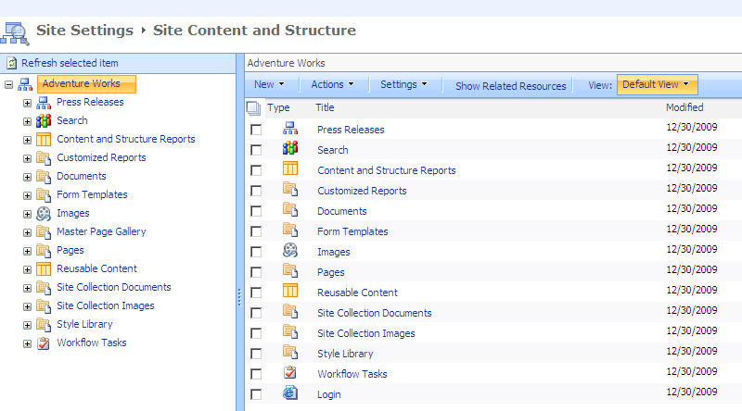

1. Click the back button in the browser to go back to the home page of the site.

In this exercise you created your first Publishing Site & modified some settings such as the site theme.

### Exercise 2: Creating Custom Page Layouts

In this exercise you will create a couple of Custom Page Layouts. But before you can do that, you will be creating a couple of Site Columns and a Content Type to base your Page Layouts upon.

1. Select **Site Actions » Site Settings**.
2. Select **Galleries** **»** **Site columns**. You will see all the site columns that currently exist on this site.

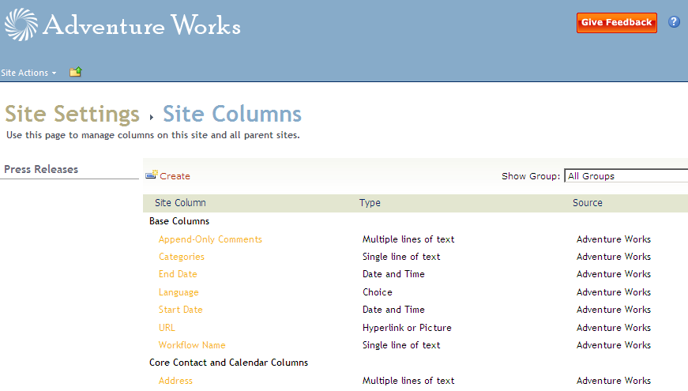

1. To create a new column, click **Create**. On the **New Site Column** page use the following information to create a new site column:

**Column Name:** Press Release Summary

**Type of information in this column is:** Full HTML content with formatting and constraints for publishing

**Group:** New Group » AW

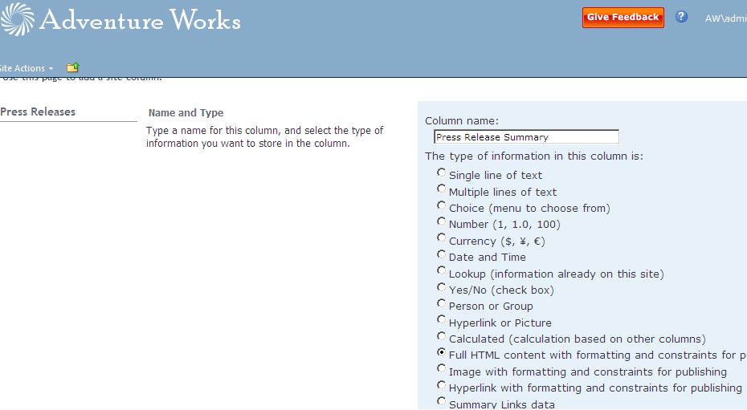

1. Create another site column using the following details:

**Column Name:** Press Release Details

**Type of information in this column is:** Full HTML content with formatting and constraints for publishing

**Group:** Existing Group » AW

After creating a site column in the browser, now create one in SharePoint Designer 2010.

1. Launch **SharePoint Designer 2010** and load the **http://intranet.wingtip.com/sites/AdventureWorks** site collection.
2. Now use SharePoint Designer 2010 to create a Content Type containing these two Site Columns.
3. Select **Content Types** in the Navigation Pane.

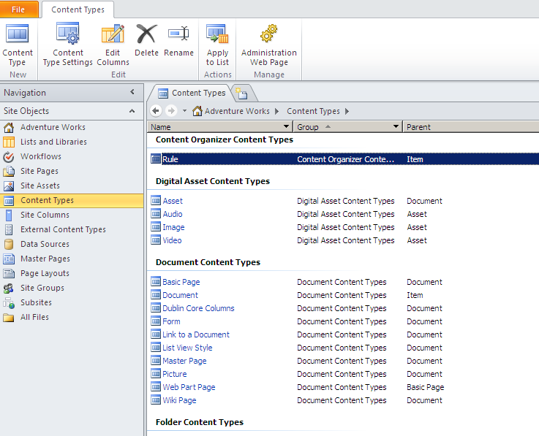

1. Click **Content Type** button in the ribbon. The **Create a Content Type** dialog box comes up. Use the following information to create the content type:

**Name:** Press Release Page

**Select parent content type from:** Page Layout Content Types

**Select parent content type:** Article Page

**Group:** New Group » AW

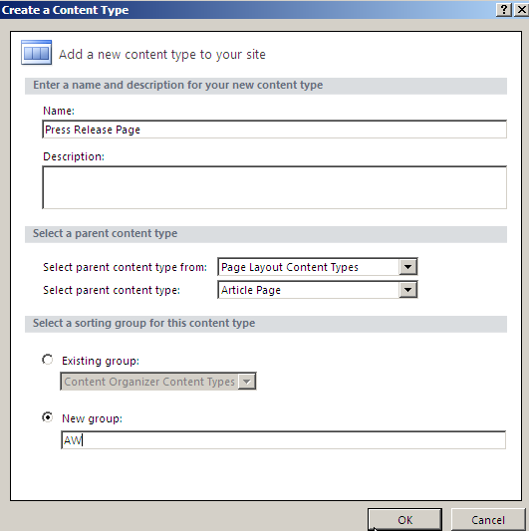

After creating the content type, select it from the list of available content types to open its **Summary Page**.

1. Click the **Edit content type columns** link under the **Customization** section. All the current Site Columns for this Content Type should now be displayed.
2. You will now add the two Site Columns that we had created earlier. Click the **Add Existing Site** **Column** button in the ribbon, select **Press Release Details** from the **Site Columns Picker** dialog box and click **OK**.

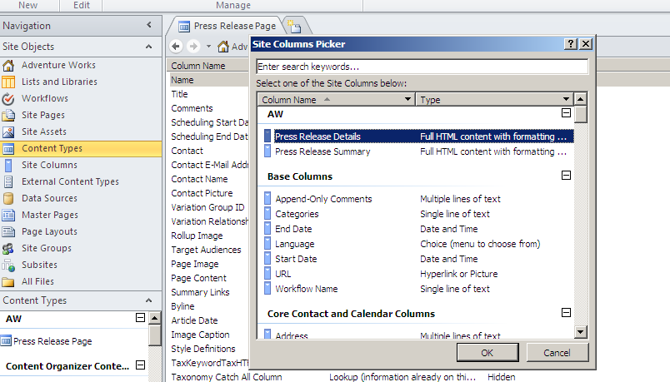

1. Repeat the process to add the **Press Release Summary** Site Column.

**Note:** If the Add Existing Site Column button in the ribbon is not enabled, click anywhere in SharePoint Designer 2010 to make the button enabled.

1. After adding the Press Release Details and Press Release Summary Site Columns click the **Save** button to save this Content Type.

You will now create a couple of page layouts based upon this Content Type.

1. Click **Page Layouts** in the Navigation Pane. You should now see all the Page Layouts that exist on this site.

**Note:** That this Page Layouts selection is only available only when you opened a Publishing Site in SharePoint Designer. It is not available when you open a Team Site in SharePoint Designer.

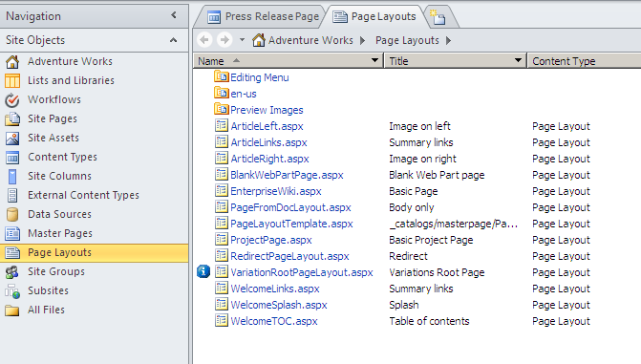

1. Click the **New Page Layout** button in the ribbon’s **New** group. From the **New** dialog box that opens use the following:

**Content Type Group:** AW

**Content Type Name:** Press Release Page

**URL Name:** PressRelease.aspx

**Title:** Press Release

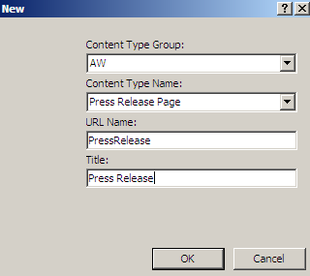

1. Click the **OK** button.
2. The **Press Release Page Layout** should now automatically open up as a new tab in SharePoint Designer 2010.
3. Place the cursor in the **PlaceHolderMain** section and use the ribbon to add a table to the page: **Insert » Table » {2 x 2 table}**.
4. Place your cursor in the **first cell** of the table. In the right-hand task pane of SharePoint Designer 2010, click the **Toolbox** tab.

**Note:** If Toolbox is not present in the Task Pane, click the **View** tab, then from the **Task Pane** button in the ribbon, select the **Toolbox** selection.

1. You should see SharePoint controls showing **Data View Controls**, **Server Controls**, **Page Fields** and **Content Fields**.

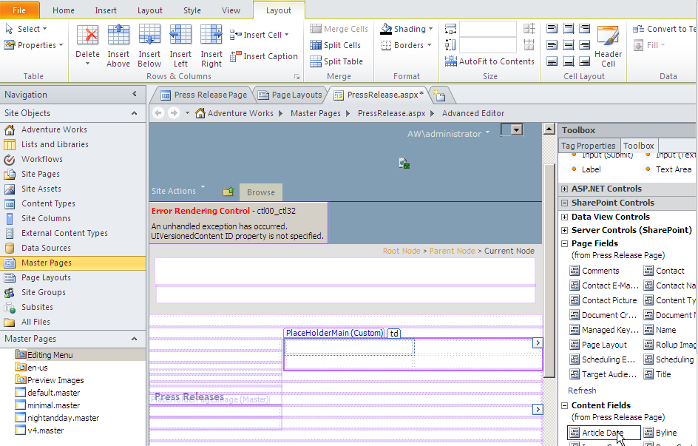

1. Now add fields from **Page Fields** and **Content Fields** section to the page.
2. Click and drag the **Title** field from **Page Fields** section into the **first cell** of the table.
3. Click and drag the **Article Date** field from the **Content Fields** section to the **second cell** of the table.
4. Now insert the Press Release Summary and Press Release Details fields in the second row of your table:
5. Click and drag the **Press Release Summary** field from the **Content Fields** section into **the second row first column** of your table.
6. Click and drag the **Press Release Details** field from the **Content Fields** section into the **second row second column** of your table.

You should now see the Title, Article Date, Press Release Summary and Press Release Details fields on your Publishing page.

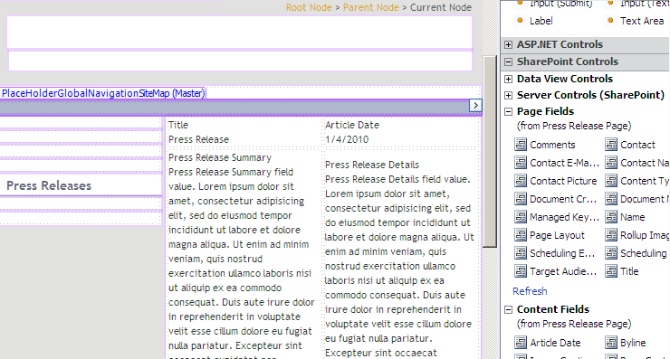

You can further make restrictions to the content of these fields. For the Press Release Summary field, you will make a restriction so the fonts in the field cannot be changed by the user who is filling out the information in the field.

1. Click the **Press Release Summary** field in the **second row first column** of your table. Click the **Tag Properties** tab in your **Toolbox** task pane and look for the **AllowFonts** attribute. It should be set to **True**. Change the setting to **False**. Click the **Save** icon on the page to save the page.

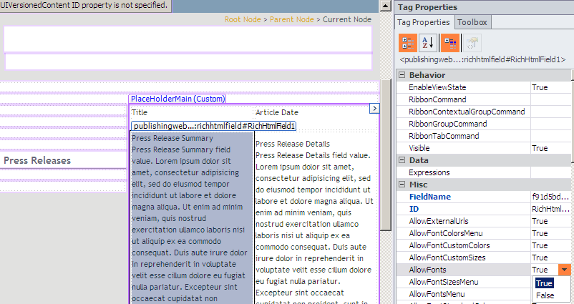

**Note:** If Toolbox is not present in the Task Pane, click the **View** tab, then from the **Task Pane** button in the ribbon, select the **Toolbox** selection.

1. You will now create a new Page Layout with the same fields arranged in a different order.
2. Click **Page Layouts** in the Navigation Pane
3. Click **New Page Layout** button in the ribbon.
4. In the **New** dialog box that appears, enter the following:

**Content Type Group:** AW

**Content Type Name:** Press Release Page

**URL Name:** PressRelease2

**Title:** Press Release 2

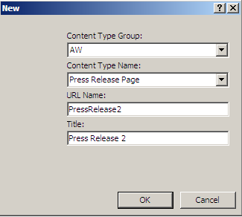

1. Click on **OK**. The PressRelease2.aspx page should now appear.
2. Click the **PlaceHolderMain** section. Using the ribbon add a table: **Insert » Table » {1 x 4 table}**.
3. Repeating the process above, add the **Title**, **Article Date**, **Press Release Summary** and **Press Release Details** fields to the page. Except this time change the layout a little so it is noticeably different from the previous page layout.
4. Click the **Save** icon to save this page.
5. Check in and approve the two Page Layouts that you just created.
6. Click **Page Layouts** in the Navigation Pane.
7. Right click PressRelease.aspx file and click **Check In** from the popup menu.
8. From the **Check In** dialog box that appears, click **Publish a major version** radio button and then click the **OK** button.

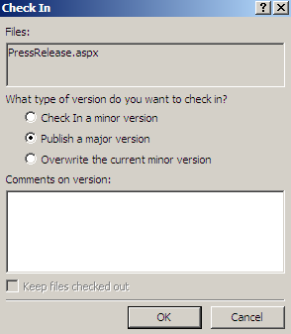

1. A dialog box appears notifying you that **This document requires content approval. Do you want to view or modify status?** Click the **Yes** button.
2. A browser window should open up showing you your submission to the **Master Page and Page Layout** gallery.
3. Hover over the **Press Release** page and click the drop down menu. Select the **Approve/Reject** option. In the **Approve/Reject** prompt that appears click the **Approved** radio button and click the **OK** button.
4. The Page Layout PressRelease.aspx is now approved. Close this browser window.

In this exercise you created a few new page layouts and content pages based off these new layouts.

### Exercise 3: Creating and Approving Publishing Pages

In this exercise you will see how you can create new Publishing Pages and how the approval process works for a Publishing Page.

1. To start, navigate to the **Adventure Works** home page in the browser: **http://intranet.wingtip.com/sites/AdventureWorks**. Make sure you are signed in as an **administrator** of the site.
2. You will add a few users to your portal.
3. Using the ribbon select **Site Actions » Site Settings**.
4. Click the **Site permissions** link in the **Users and Permissions** section.
5. Click the **Adventure Works Members** group.
6. Click the **New** button.
7. From the **Grant Permission** dialog box that appears, type **ken** in the text box for **Users/Groups**. Click the person check icon to check the name. **Ken Sanchez** should now be resolved. Click the **OK** button.

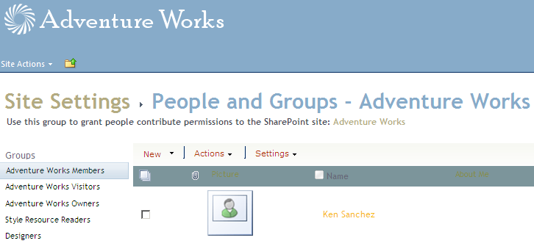

1. In the left side of the page, click the **Adventure Works Visitors** link. Click the **New** button and add **Michael Sullivan** to the **Visitors** group.
2. Now click the **Approvers** group and add **Rob** and **Janice** to the **Approvers** group.
3. Click the **Adventure Works** link in the top navigation of the page to get to the home page.
4. Sign in as **Ken** on to this page. Ken Sanchez is a member of this site. He will now create a new page on the site.
5. Using the ribbon select **Site Actions » New Page**.
6. In the **New Page** dialog box that pops up, type in the page name **New Product Launch**. Click the **Create** button.
7. You will now change the Page Layout to Press Release.
8. Click the **Page Layout** button in the ribbon and select **Press Release**.

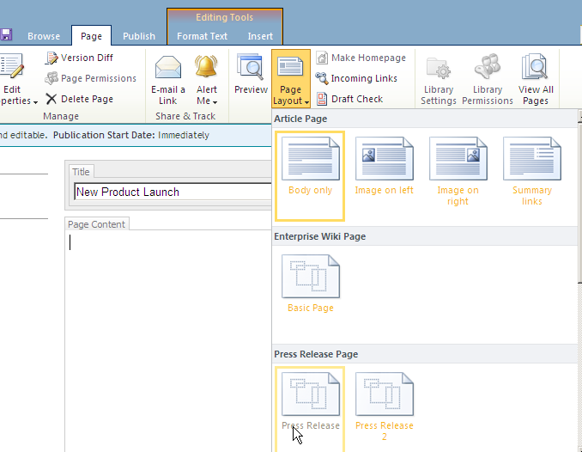

1. The **Title** of the page should already be pre-populated with **New Product Launch**.
2. Set the **Article Date** to be two days from today.
3. Click the link **Click here to add new content** under **Press Release Summary**. You will add Press Release Summary here. Add some content by typing anything in this field.
4. Repeat the process for the **Press Release Details** field and enter some text.

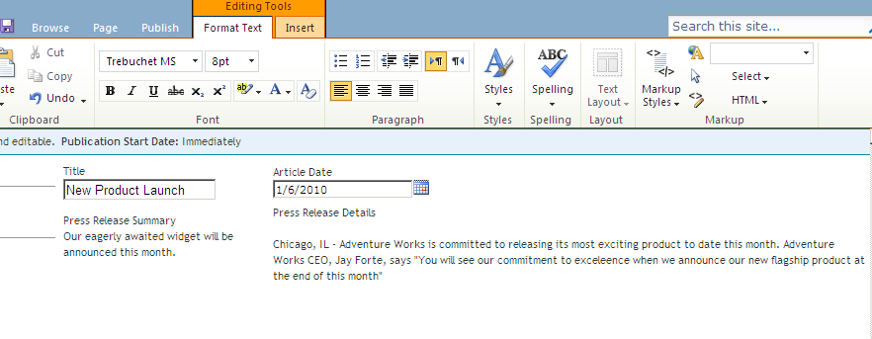

1. Once you have created the content of Press Release Summary and Press Release Details in the Press Release Page, click and select the some of the text in the **Press Release Details** field and highlight it using the ribbon: under the **Editing Tools** contextual tab group select **Format Text » Styles » Highlight**.
2. Now click the text under **Press Release Summary**. Notice that the **Formatting Text Tools** are disabled. The reason these are disabled is because the **Page Layout** has **the Press Release Summary** field control attribute **AllowFonts** property to be **False**.

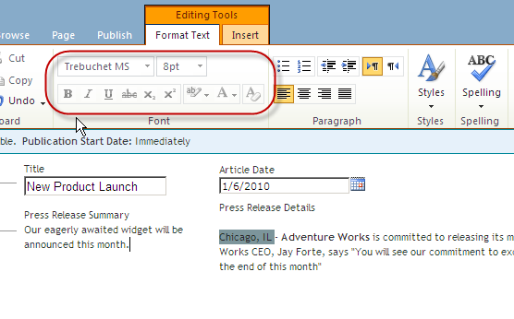

1. Click the **Press Release Details** section to insert a picture.
2. Using the ribbon: under the **Editing Tools** contextual tab group select **Insert » Picture » From SharePoint**.
3. Click the **Site Collection Images** library and select the **PR** image.
4. Click on **OK**.

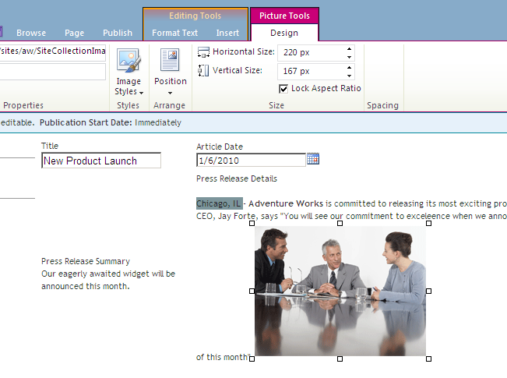

You have inserted a pre-approved image that was in the Site Collection Images library to this page.

1. To format this image click use the ribbon:
2. From the **Picture Tools** contextual tab group select **Design**.
3. Change the **size** to be half of the original picture.
4. Click the **Design » Position** button and change the **Float** position to **Right**.

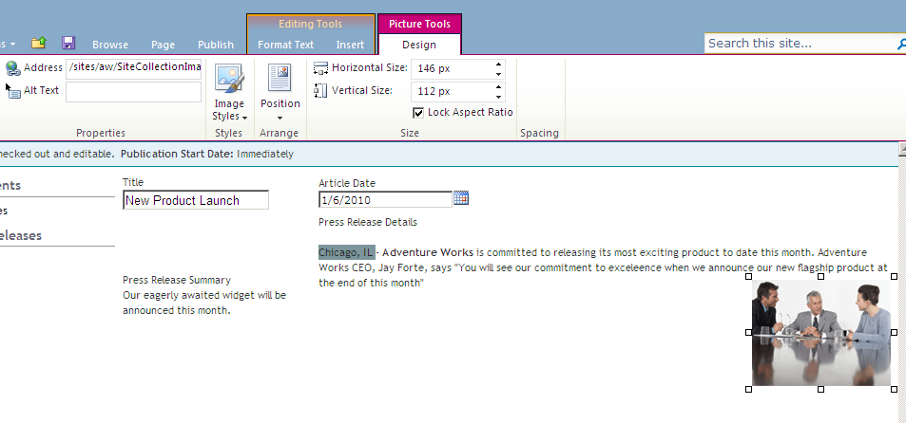

1. You are now ready to publish this page. Since **Ken Sanchez** is a member and not an approver of the site, he will have to submit this page to the publishing process.
2. Click the **Publish** tab in the ribbon and click the **Submit** button.
3. The **Submit for Approval** dialog box will check the spelling of the content on the page. Click past any errors that are found by clicking **Continue**.
4. The **New Product Launch** workflow page should now appear.
5. Type in the message **Press Release about our new secret product in the notification message** text box.
6. Set the **Due Date for All Tasks** to be tomorrow.
7. Click the **Start** button.

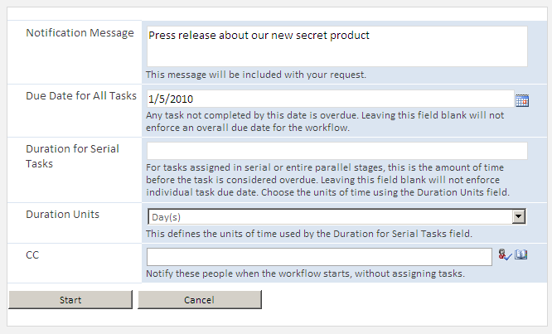

The workflow for publishing the page has now started.

1. Click the **Adventure Works** logo on the top left of the page to get to the home page of the portal.
2. Sign in as **Janice**. **Janice Galvin** should be signed in to the page. Janice is an approver of the site and will now go and approve the page submitted by Ken.
3. Select **Site Actions » View All Site Content » Workflow Tasks**.

There should be one task in the **Workflow Tasks** list assigned to **Approvers**.

1. Click the **Task Title**. In the **Workflow Task** dialog box that comes up, type in **Comments**: **Looks Good**.
2. Click the **Approve** button.

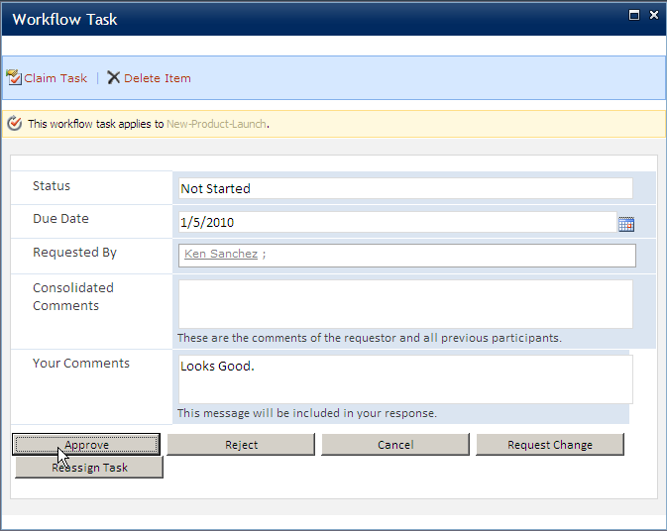

Janice has now approved his page and this page is now visible to all users of the site.

1. Click the **Site Actions » View All Site Content » Pages**. The **New Product Launch** page should appear here. Click on it to navigate to it.
2. Once at the **New Product Launch** page, sign in as **Ken Sanchez** once again.
3. You will now update the content of this page. In the ribbon, click **Page » Edit**.
4. In the ribbon, click **Page » Page Layout » Press Release 2**.

You have now changed the layout of the page to Press Release 2 Page Layout.

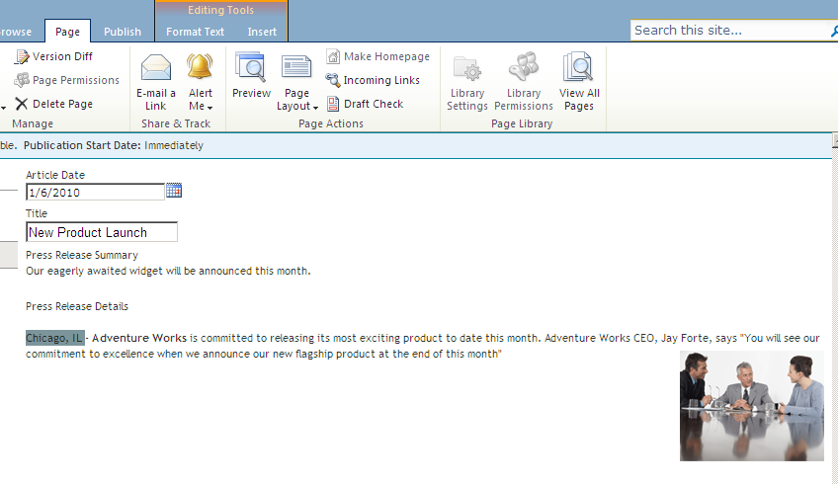

1. Try changing the text of **Press Release Summary** formatting such that some of words are in bold. You should be able to do so since this Page Layout does allow you to change the font in Press Release Summary.

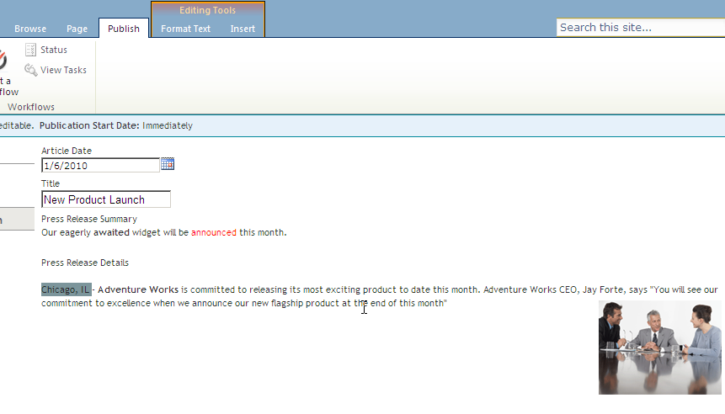

1. Submit this page again for approval by clicking on the **Publish » Submit**.
2. Click the **Continue** button in the **Submit for Approval** box.
3. In the form that appears, click the **Start** button.
4. Since Ken has made some changes in this page and the page has not been approved yet, this page is only visible in its current state to the visitors of this site.

To check that, sign in as **Michael** on this page.

1. Michael should see this page in its current format and not the changes that Ken has made which have not been approved yet.
2. Now sign in to the same page as **Rob**. Rob should see that this page is awaiting approval. Click **Publish » Approve**.
3. In the **Approve** dialog box that comes up, click **Continue** and then in the form that comes up, type in Comments: **Great**.
4. Click the **Approve** button.
5. The page has now been approved and published.
6. Sign back into the page as **Michael** to make sure that Michael who is a visitor of this site can see the new changes.

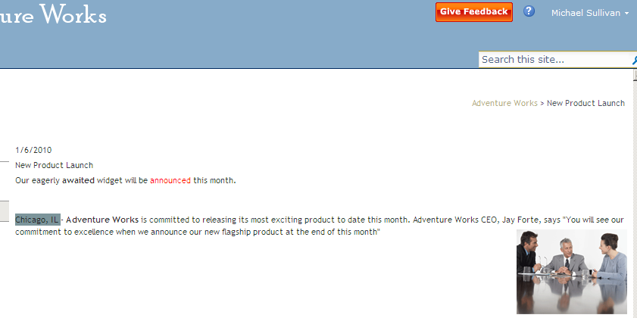

In this exercise you created a few content pages and interacted with them using the publishing approval process.